
Hillcrest Primary School
A Guide for Parents and Carers: Supporting maths at home.
The purpose of mathematics in our school is to develop:

- positive attitudes towards the subject and awareness of the relevance of mathematics in the real world
- competence and confidence in using and applying mathematical knowledge, concepts and skills
- an ability to solve problems, to reason, to think logically and to work systematically and accurately
- initiative and motivation to work both independently and in cooperation with others
- confident communication of mathematics where pupils ask and answer questions, openly share work and learn from mistakes
- an ability to use and apply mathematics across the curriculum and in real life
- an understanding of mathematics through a process of enquiry and investigation
- We aim to provide a stimulating and exciting learning environment that takes account of different learning styles and uses appropriate resources to maximise teaching and learning.

Introduction
Mathematics is a creative and highly inter-connected discipline that has been developed over centuries, providing the solution to some of history’s most intriguing problems. It is essential to everyday life, critical to science, technology and engineering, and necessary for financial literacy and most forms of employment. A high-quality mathematics education therefore provides a foundation for understanding the world, the ability to reason mathematically, an appreciation of the beauty and power of mathematics, and a sense of enjoyment and curiosity about the subject. (National Curriculum 2014)

EYFS
The EYFS Statutory Framework 2014 sets standards for the learning, development and care of pupils from birth to five years old and supports an integrated approach to early learning. This is supported by the ‘Development Matters’ non statutory guidance as well as the White Rose Medium Term plans for EYFS Mathematics. The EYFS Framework in relation to mathematics aims for our pupils to:

- develop and improve their skills in counting
- understand and use numbers
- calculate simple addition and subtraction problems
- describe shapes, spaces, and measures

The move to maths mastery at Hillcrest
The updates to the 2014 curriculum have placed an emphasis on mastery, fluency and problem-solving in maths. In a nutshell, the onus is on a deep understanding of mathematical concepts, rather than learning strategies and facts by off by heart, and this is something to bear in mind as you look to help your child with maths throughout KS1 and KS2. Approaches like concrete-pictorial-abstract, open up the inner workings of mathematical concepts and allow us to really take a look at what we’re doing with numbers.

Studies have shown that by using concrete maths resources items in the first phase of learning, children are more able to understand pictorial representations (like pictograms or bar models) in the second phase of learning. These two steps make the abstract phase of learning (when there are only numbers involved) seem like a completely natural progression. Using these steps is a great way to help your child understand the way that maths applies to the real world, and it means that they will be well-equipped to deal with all sorts of mathematical conundrums.

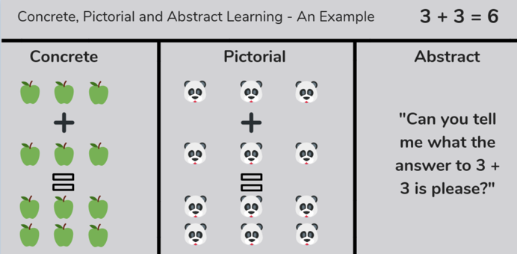

How to support your child at home:
EYFS/YEAR 1/YEAR 2
Spot numbers in everyday life spot numbers and talk about them.
Counting count forward and backward in steps of 1, 2, 5 and 10.
Match number to value play games matching numbers to objects.
Number Bonds, recall number bonds to 10 and 20.
Multiplication and division count in 2, 5 and 10’s. Share and group items equally.
Year 3/Year 4
Timetables practise, practise, practise! They are the foundation of many areas of maths and will set your child up well.
Link to the real world Maths is all around us. Find any opportunity to immerse your child.
Measure everything and anything – cultivating accuracy as a habit.
Challenge them: play games, card games, board games and dice games.
Print off some nets and make some 3D shapes.
Year 5/Year 6
Short and sweet / Make it Fun!
- Spotting Maths everywhere
Read the time …all the time!
- Use analogue clocks
Negative Numbers
- Make it practical

Useful websites

TTRockstars: https://ttrockstars.com/
Numbots: https://play.numbots.com/#/intro
BBC Bitesize KS1: https://www.bbc.co.uk/bitesize/subjects/zjxhfg8
BBC Bitesize KS2: https://www.bbc.co.uk/bitesize/subjects/z826n39
Hit the Button: https://www.topmarks.co.uk/maths-games/hit-the-button
TopMarks (Maths Games): https://www.topmarks.co.uk/Search.aspx?Subject=16
Third Space Learning: https://thirdspacelearning.com/blog/

